**GetIN Mobile on family planning**

At sixteen years, many girls are still in school, concentrating on completing their education and dreaming of becoming of what they aspire to be in their communities. But this was not the case for sixteen year-old Sharon (not real names) who was married off and today, is seven months pregnant after her husband insisted she started bearing children and refused her to use any method of family planning.

Sharon’s ordeal is a common scenario, similar to many young mothers in living in Kanungu district and even Uganda as a whole. Even where they want to, they cannot access family planning to prevent unwanted pregnancies or delay it.

One midwife at Matanda Health Center III says this unmet need for family planning has led to an increase in unplanned pregnancies:

“Some women and young girls come to us crying, blaming us for their unwanted pregnancies because when we couldn’t help them,” she said.

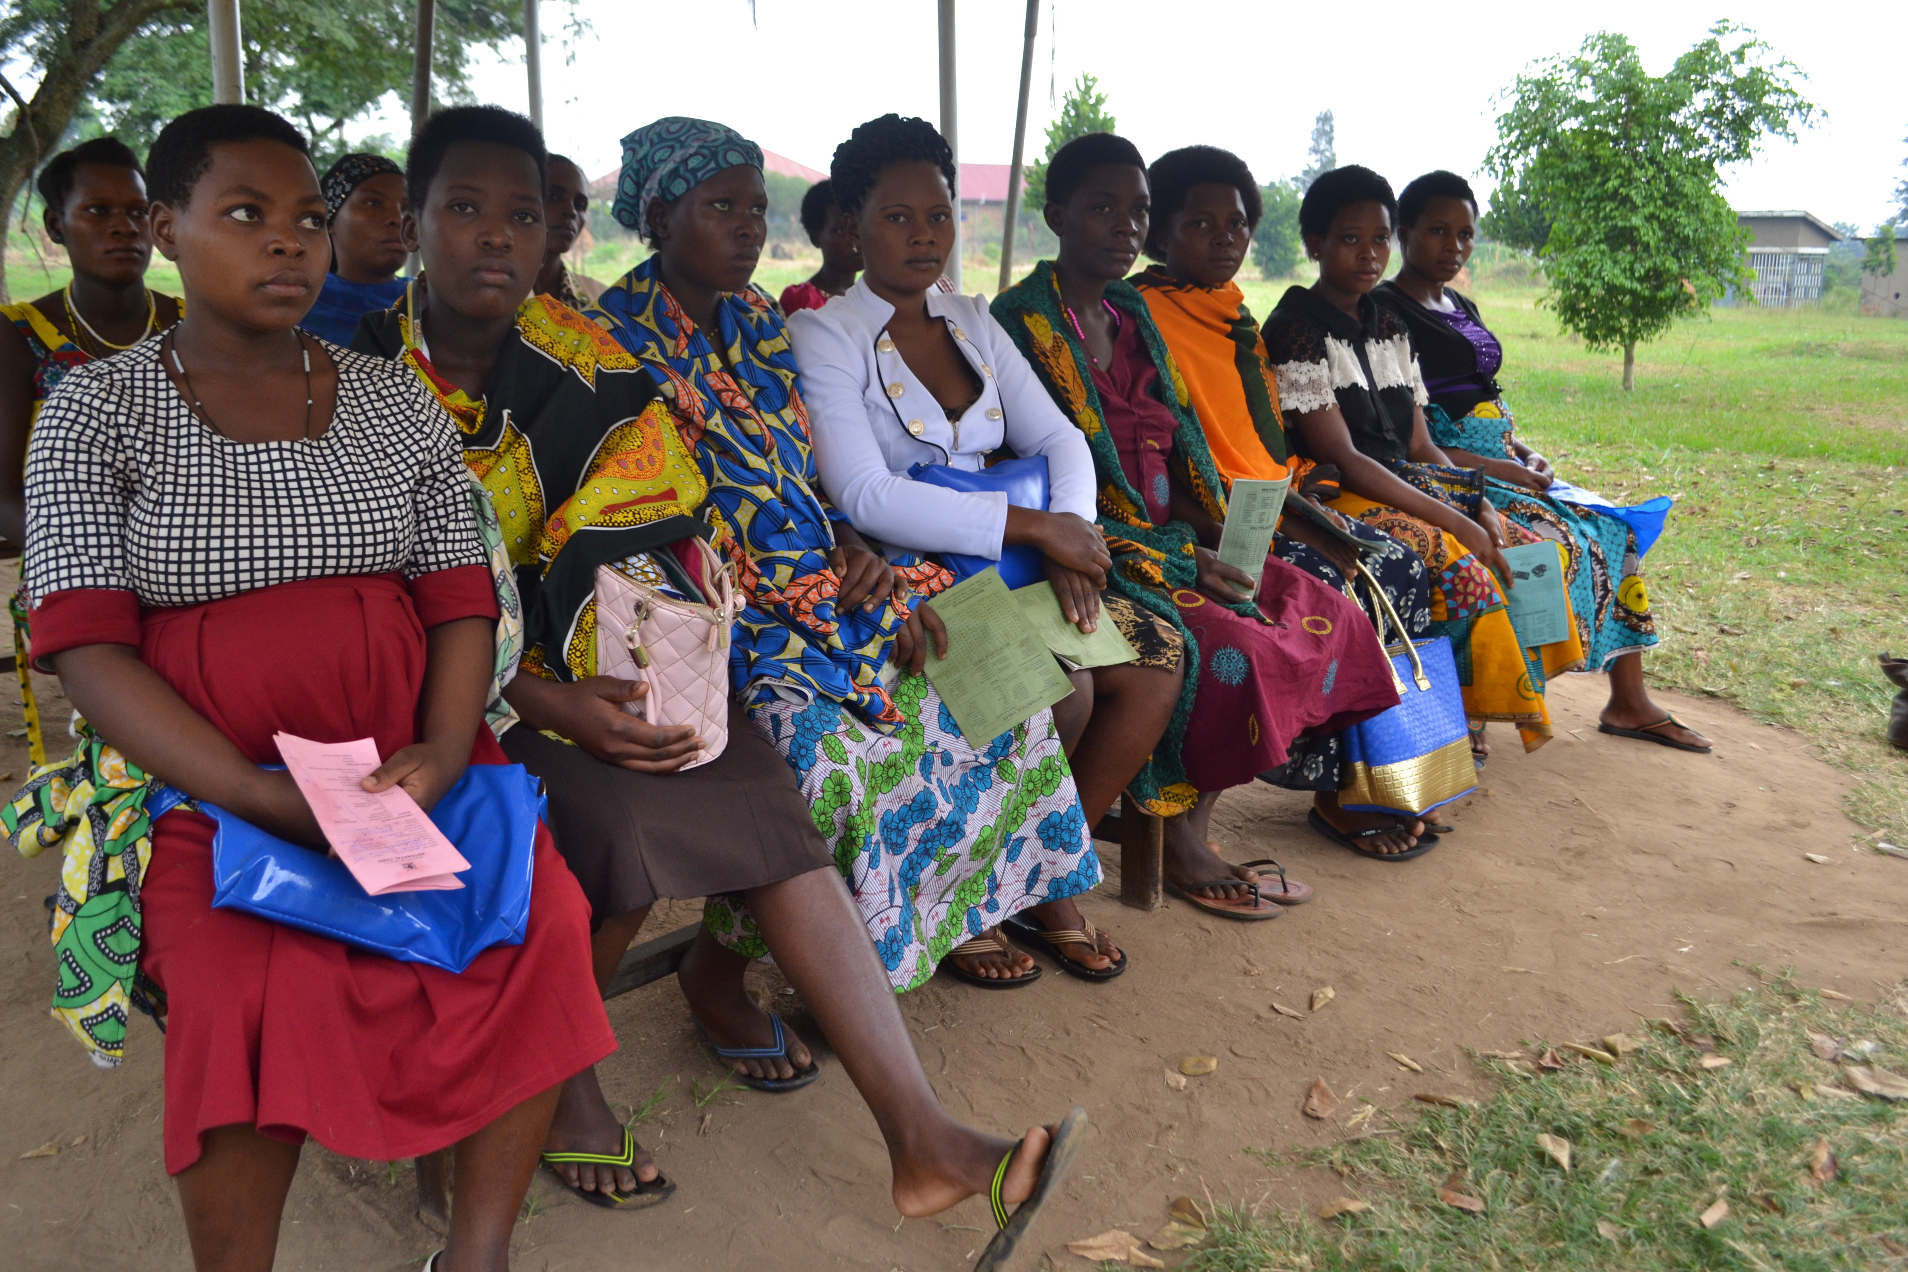**Some of the young pregnant girls (16-21years) waiting for their ANC appointment**

Another midwife from Bundibugyo says she interacted with a young mother, 21 years old and was on her eighth pregnancy. She had high blood pressure and was gravida 7 (number of births) so the midwife got worried and tried to counsel her she got on the defensive and told the midwife off. (How can a 21 year-old have 7 children? Please check this)

This girl might have or may still want to use family planning but it is probably not a choice considering many factors (what are these many factors?)

In Uganda, one in every four girls is either pregnant with her first child or has had a baby. Many girls will also get pregnant again within 24 months of their last pregnancy, increasing the likelihood of maternal morbidity including risks like obstetric fistula, still births and even death.

With GetIN Mobile the relationship and communication between the Community Health Extension Workers (CHEWs), midwives and pregnant girls is strengthened by ensuring that all young mothers are informed on the different methods and benefits of family planning.

The different methods and advantages after delivery by sending health SMS to these girls till six weeks postpartum and also the app provides means of the health workers calling the girls and vice versa in cases of need (Explain more).

With GetIN Mobile we shall see more retention of others in ANC, more mothers taking on family planning and safe deliveries at health centers.